**Burundi country profile**

Published

24 June

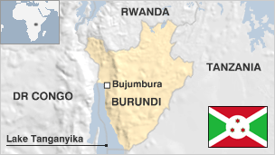

**Burundi, one of the world's poorest nations, is struggling to emerge from a 12-year, ethnic-based civil war.**

Since independence in 1962 it has been plagued by tension between the usually-dominant Tutsi minority and the Hutu majority.

A civil war, sparked off in 1994 made Burundi the scene of one of Africa's most intractable conflicts.

Read more [country profiles](http://news.bbc.co.uk/1/hi/country_profiles/) - Profiles compiled by [BBC Monitoring](http://bbc.co.uk/monitoring)

**President: Evariste Ndayishimiye**

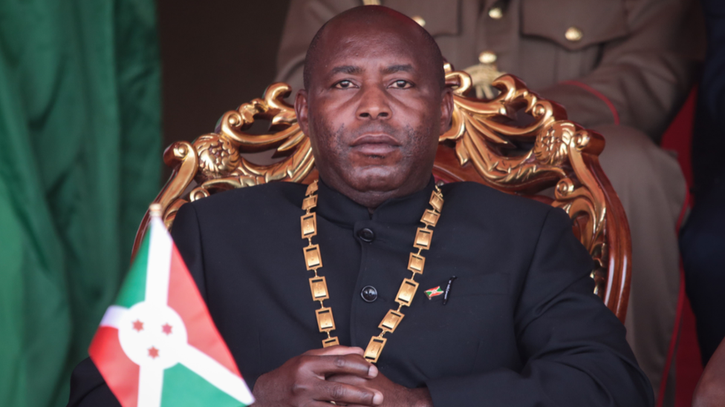image copyrightGetty Images

Evariste Ndayishimiye took office in June 2020, a week after President Pierre Nkurunziza died suddenly in the midst of the Covid-19 pandemic.

Mr Ndayishimiye had won the May presidential election, and was due to take office in August.

The opposition condemned the election, in which Mr Ndayishimiye had the backing of his fellow former Hutu rebel leader Pierre Nkurunziza, as rigged. Mr Nkurunziza was the first president to be chosen in democratic elections since the start of Burundi's civil war in 1994.

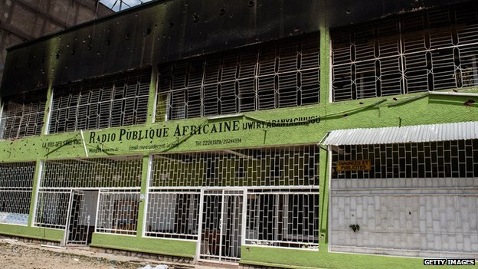image copyrightGetty Images

image captionAn independent radio station was destroyed by supporters of President Nkurunziza

State-run outlets dominate the media. Journalists operate under strict press laws and face harassment.

Many privately-owned radio stations were shut after a 2015 coup attempt and most remain closed. Local relays of the BBC and Voice of America have been suspended.

**Burundi profile - Timeline**

Published

3 December 2018

**Chronology of key events:**

**pre-1300s** - Hutu people settle in the region.`

**1400s** - Tutsi settlers arrive.

**1500s** - Distinct Burundian kingdom emerges.

**1890** - The kingdoms of Urundi and neighbouring Ruanda (Rwanda) incorporated into German East Africa.

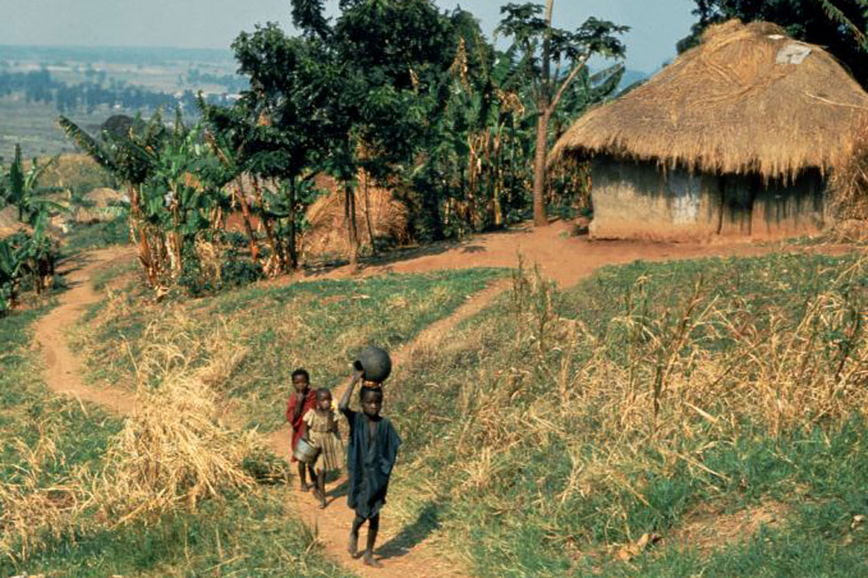image copyrightGetty Images

image captionChildren in rural Burundi

**1916** - Belgian army occupies the area.

**1923** - Belgium receives League of Nations mandate to administer Ruanda-Urundi.

**1959** - Influx of Tutsi refugees from Ruandam half of the territory following ethnic violence there.

**1959-1961** - Independence drive led by cross-communal UPRONA party of Prince Louis Rwagasore, which wins 1961 legislative elections. Prince Louis becomes prime minister of Ruanda-Urundi but is assassinated shortly afterwards.

**Independence**

**1962** - Urundi secedes and becomes independent kingdom of Burundi, under King Mwambutsa IV.

**1963** - Thousands of Hutus flee to Rwanda following ethnic violence.

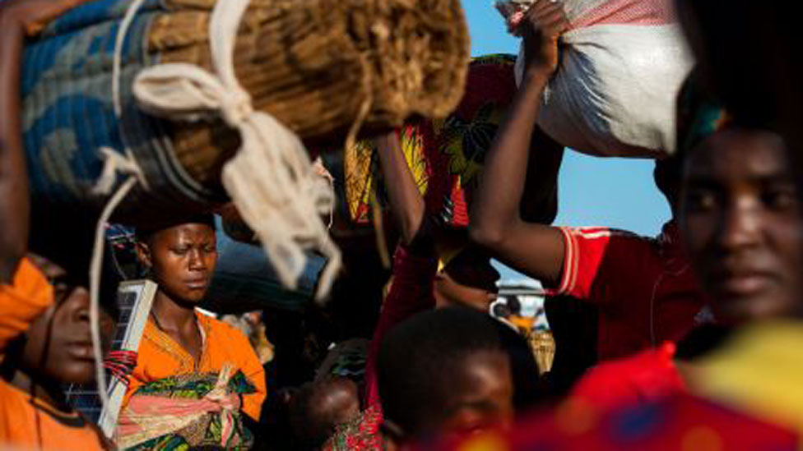image copyrightGetty Images

image captionRefugees flee violence in Burundi in 2015, which has seen several episodes of inter-ethnic strife

**1965** - King Mwambutsa refuses to appoint a Hutu prime minister after Hutus win a majority in parliamentary elections; attempted coup put down by army chief Michel Micombero.

**1966** - Michel Micombero abolishes the monarchy and declares himself president.

**Massacres and one-party rule**

**1972** - About 120,000 Hutus are massacred by government forces and their supporters in the wake of a Hutu-led uprising in the south.

**1976** - President Micombero is deposed in a military coup by Jean-Baptiste Bagaza.

**1981** - A new constitution makes Burundi a one-party state under UPRONA.

**1987** - President Bagaza is deposed in a coup led by Pierre Buyoya.

**1988** - Thousands of Hutus are massacred by Tutsis, and thousands more flee to Rwanda.

**Dashed hopes**

**1992** - New constitution providing for a multiparty system is adopted in a referendum.

**1993 June** - Melchior Ndadaye's Frodebu wins multi-party polls, ending military rule and leading to the installation of a pro-Hutu government.

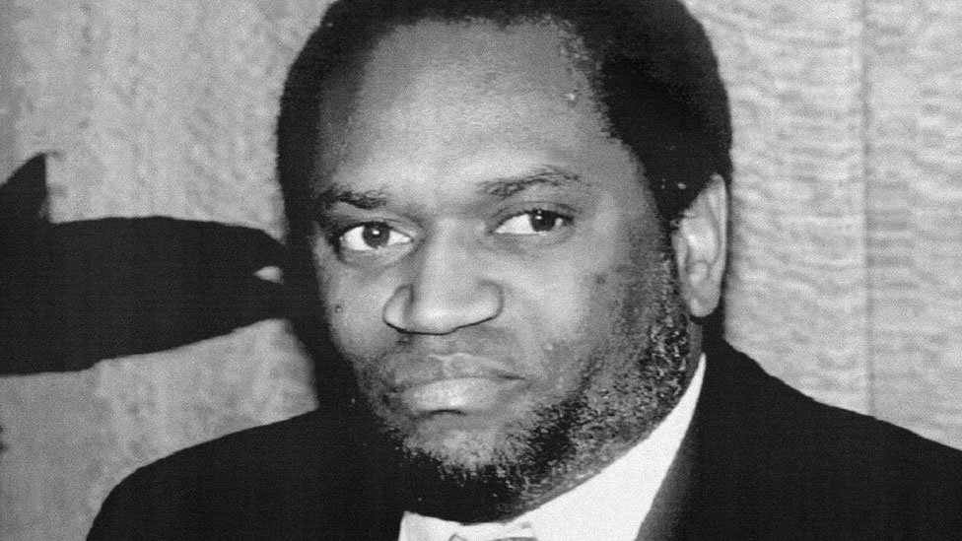image copyrightGetty Images

image captionMelchior Ndadaye was assassinated in 1993

**1993 October** - Tutsi soldiers assassinate President Ndadaye. In revenge, some Frodebu members massacre Tutsis, and the army begins reprisals. Burundi is plunged into an ethnic conflict which claims some 300,000 lives.

**1994 January** - Parliament appoints a Hutu, Cyprien Ntaryamira, as president.

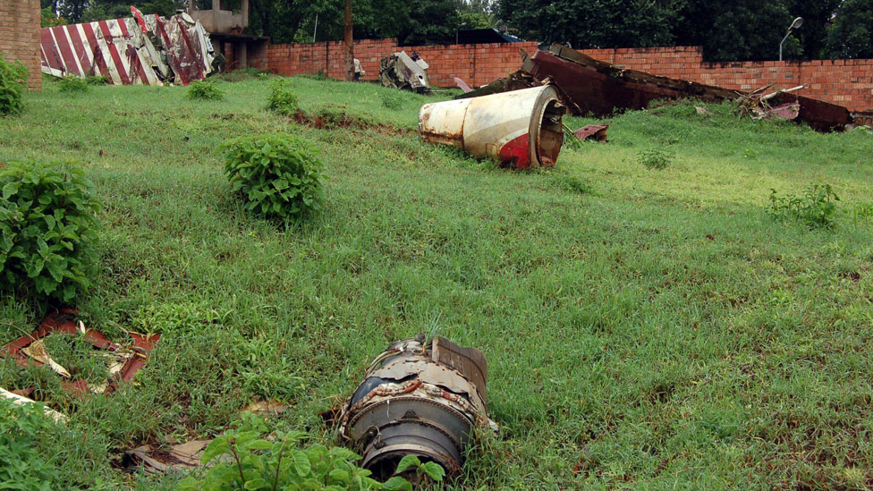image copyrightAFP

image captionWreckage from the plane crash in which killed Burundi's former President Ntaryamira and his Rwandan opposite number

**1994 April** - Plane carrying President Ntaryamira and his Rwandan counterpart is shot down over the Rwandan capital Kigali, killing both and triggering genocide in Rwanda in which 800,000 are killed.

**1994 October** - Parliament speaker Sylvestre Ntibantunganya appointed president.

**1995** - Massacre of Hutu refugees leads to renewed ethnic violence in the capital, Bujumbura.

**Buyoya returns**

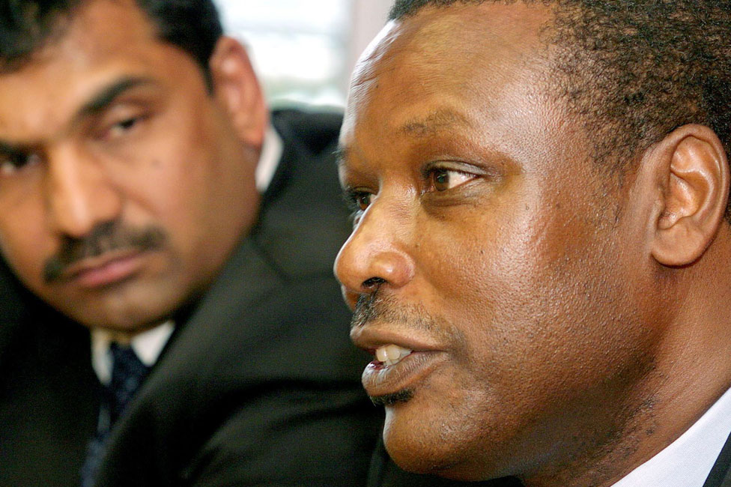image copyrightGetty Images

image captionPierre Buyoya (R) seized power twice

**1996** - Ex-president Buyoya seizes power.

**Transitional government**

**2001** October - Talks brokered by South African President Nelson Mandela lead to installation of transitional government, but main Hutu rebel groups refuse to sign and fighting intensifies.

**2003** April - Domitien Ndayizeye - a Hutu - succeeds Pierre Buyoya as president, under terms of three-year, power-sharing transitional government inaugurated in 2001.

**2003** July - Major rebel assault on Bujumbura. Some 300 rebels and 15 government soldiers are killed. Thousands flee their homes.

**2003** November - President Ndayizeye and Hutu rebel group Forces for Defence of Democracy (FDD) leader Pierre Nkurunziza sign agreement to end the civil war at summit of African leaders in Tanzania. Smaller Hutu rebel group, Forces for National Liberation (FNL), remains active.

**2004** - UN force takes over peacekeeping duties from African Union troops.

**2005** January - President signs law to set up new national army, incorporating government forces and all but one Hutu rebel group, the FNL.

**Nkurunziza becomes president**

**2005** August - Pierre Nkurunziza, from the Hutu FDD group, is elected as president by the two houses of parliament. The FDD won parliamentary elections in June.

**2006** April - A curfew, imposed during the violence of 1972, is lifted.

**2006** September - The last major rebel group, the Forces for National Liberation (FNL), and the government sign a ceasefire at talks in Tanzania. Sporadic clashes recur over the next two years.

**2007** February - UN shuts down its peacekeeping mission and refocuses its operations on helping with reconstruction.

**2007** April - DRCongo, Rwanda and Burundi relaunch the regional economic bloc - Great Lakes Countries Economic Community - known under its French acronym CEPGL.

**2007** December - Burundian soldiers join African Union peacekeepers in Somalia.

**Peace agreement**

**2009** March - The Paris Club of creditor nations cancels all of the $134.3m debt Burundi owed to its members.

**2009** April - FNL lays down arms and officially becomes a political party in a ceremony supervised by the African Union.

**2010** June - President Nkurunziza re-elected in uncontested poll after main opposition parties boycott the vote.

**2013** June - President Nkurunziza approves new media law which critics condemn as an attack on press freedom.

**2013** August - The leader of the former rebel FML, Agathon Rwasa, resurfaces after three years in hiding and says he will stand in the 2015 presidential election.

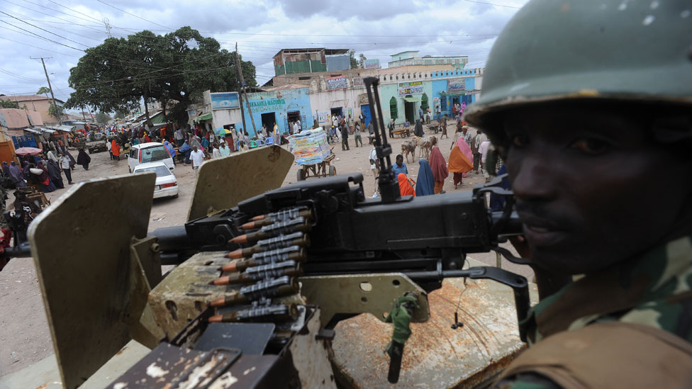image copyrightGetty Images

image captionBurundian troops have been part of an African Union peacekeeping mission in Somalia since 2007 and have suffered some casualties

**2014** March - Parliament blocks a government attempt to introduce changes to the constitution seen as threatening the balance of power between the country's main ethnic groups.

**Authoritarian moves**

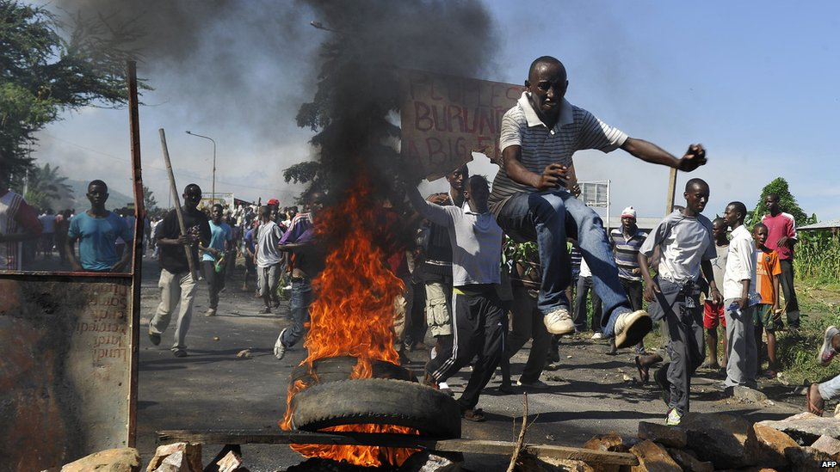image copyrightAFP

image captionPresident Pierre Nkurunziza's decision to stand for a third term prompted months of protests

**2015** May - Constitutional Court rules in favour of President Nkurunziza's decision to stand for a third term, amid reports of judges being intimidated. Protestors take to the streets and tens of thousands flee the violence. An army officer's coup attempt fails.

**2015** July - President Nkurunziza wins a third term in the presidential election with 70% of the vote. Opposition leader Agathon Rwasa describes the polls as a "joke".

**2016** January - President Nkurunziza threatens to counter the deployment of external peacekeepers after the African Union announces plans to send in 5,000 troops to protect civilians from escalating violence between government and rebel forces.

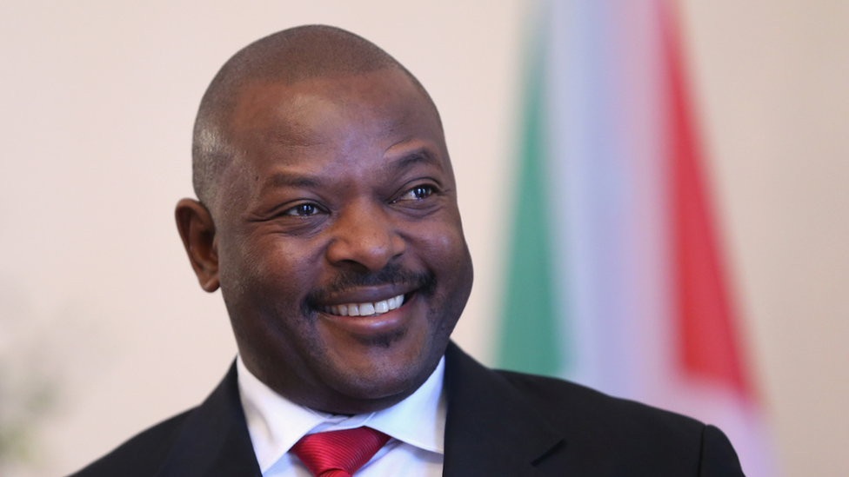image copyrightSean Gallup/Getty Images

image captionCritics accused Pierre Nkurunziza of authoritarian tendencies

**2016** March - With the political situation showing little sign of improvement, the EU announces that it is suspending direct financial aid to the Burundian government.

**2017** October - Burundi becomes the first ever country to leave the International Criminal Court (ICC).

**2017** November - ICC judges approve the opening of a full investigation into alleged crimes against humanity in Burundi, where at least 1,200 people have died in unrest since 2015.

**2018** May - Official results say a referendum backed constitutional reforms that could allow President Nkurunziza to stay in office for another sixteen years.

**2018** December - Burundi issues international arrest warrant for former president Pierre Buyoya over the killing of President Melchior Ndadaye in 1993. Mr Buyoya's supporters say the move is politically motivated.

**2019** April - Capital moved to Gitega, although Bujumbura remains the commercial capital.

**2020** June - Former Hutu rebel leader Evariste Ndayishimiye takes office as president, a week after President Pierre Nkurunziza died suddenly in the midst of the Covid-19 pandemic.